1. Analysis of Variance (ANOVA)

Analysis of Variance (ANOVA) comprises a variety of statistical methods. It is especially useful for comparing the means of several groups. Today we'll focus on the simplest form of ANOVA called One-way ANOVA – so called because the groups compared are differentiated only by a single factor (e.g., location of a manufacture plant). More complex ANOVA may consider multiple differentiating factors (e.g., plants in different countries and using different equipment and different processes, etc.).

One-way ANOVA

One-way ANOVA can be understood as a generalization of the independent groups t-test, where there are more than two groups.

For example, suppose we have three different plants to manufacture batteries. We want to know if the average voltage of batteries produced is the same across plants. Suppose we take a random sample of five batteries from each plant, measure output voltage, and calculate each sample's mean.

Plant 1 |  | Plant 2 |  | Plant 3
12.2 |  | 13.2 |  | 12.1
12.4 |  | 12.8 |  | 11.4
11.9 |  | 14.0 |  | 11.3
12.3 |  | 12.5 |  | 11.8
12.0 |  | 12.2 |  | 12.1
$${\overline{X}}_{1}$$ |  | $${\overline{X}}_{2}$$ |  | $$\overline{X}3$$

Our null and alternative hypotheses parallel those of an independent-groups t-test:

H₀: μ₁ = μ₂ = … = μ_{c}
H₁: Not all μ_{j} are equal (where j = 1, 2, …, c)

Where c is the number of groups (here, 3). That is, our null hypothesis is that the population means of batteries produced by all three plants (each plant's batteries is considered a population) are the same.

Intuitive Explanation

One-way ANOVA can be understood as follows. If there is some systematic difference between our groups then we would expect to see statistically significant differences between group means.

How do we assess 'statistically significant differences?'

First, we measure the actual variability of group means. Let's call this our empirical estimate of variability between groups.

Then we need a 'benchmark' to compare this variability to in order to see whether the observed variability reflects something more than simple sampling error.

But we have a benchmark: we can estimate variability within each group, and pool all these estimates. This is our best estimate of the sample variance (and sample standard deviation) for this variable. We also know that from the standard deviation of a variable, we can estimate the standard error – which is the estimated variability of sample means. Let's call this our theoretical estimate (under the null hypothesis) of variability of means.

Thus we have two estimates of the variability of sample means: our empirical estimate, and the estimate expected under the null hypothesis. If the former is significantly larger than the latter, we may reject the null hypothesis.

Statistical Calculations

Let there be c groups.
Let n_{j} denote the number of cases in group j.
Let N denote the total number of cases, N = n₁ + n₂ + … n_{c.}

One-way ANOVA is based on computation of three terms called "sums of squares" – so called because each represents a sum of squared deviations from a mean.

Between-Group Sum of Squares

This is the basis of our 'empirical estimate' of variability amongst group means.

SSB = $\sum_{j=1}^{c}{n_{j}({\overline{X}}_{j}−\overline{\overline{X}})^{2}}$

The X with two bars above it is the grand mean (i.e., the overall mean considering all cases):
Grand Mean = $\overline{\overline{X}}=\frac{\sum_{j=1}^{c}{\sum_{i=1}^{n_{j}}{X_{\text{ij}}}}}{N}$

If each group has the same number of cases, the grand mean is equal to the mean of the sample means (hence the symbol $\overline{\overline{X}}$).

Within-Group Sum-of-Squares

This term is the basis for obtaining the predicted (under the null hypothesis) estimate of variability of group means. It is based on a pooled estimate of within-group variability:

SSW = $\sum_{j=1}^{c}{\sum_{i=1}^{n_{j}}{(X_{\text{ij}}−{\overline{X}}_{j})^{2}}}$

Total Sum of Squares

Finally, we can calculate something called the total sum of squares, or the sum of squared deviations of all cases from the grand mean.

SST = $\sum_{j=1}^{c}{\sum_{i=1}^{n_{j}}{(X_{\text{ij}}−\overline{\overline{X}})^{2}}}$

We do not actually need this term, but it is interesting to note that:

SST = SSB + SSW

Mean Squares

From these sums of squares, we compute the further quantities:

Mean square between groups = $\text{MSB}=\frac{\text{SSB}}{c−1}$

Mean square within groups = $\text{MSW}=\frac{\text{SSW}}{N−c}$

"Mean square" means "average squared deviation." Recalling the definition of a variance as an average squared deviation from the mean, we see that these are variance estimates. In fact, these are our empirical and theoretical estimates of variability between group means.

To test our null hypothesis, we compute the quantity

$$F=\frac{\text{MSB}}{\text{MSW}}$$

If F is significantly larger than 1, it means that the empirical estimate of variability between group means is significantly larger than the theoretical estimate under the null hypothesis that all populations have the same mean, and we reject H₀.

The degrees of freedom for the F test are c–1 and N – c. What these mean we address in the next section.

Post Hoc Comparisons

If our F statistic is statistically significant, it implies (but does not prove) that there are meaningful differences between groups. However it does not tell us which groups are significantly different from which other groups. To narrow down the source of differences, we may perform post hoc analysis, which essentially compares each group mean with every other group mean, looking for a significant difference. In principle, this isn't much different from performing an independent groups t-test for each pair of groups. However, because we are performing many tests, we must reduce the α level for each test. Note that in performing, say, 20 statistical tests, each with α = 0.05, we would might expect at least one to be statistically significant by chance alone.

For more information about one-way ANOVA, see the text, pp. 472–480; and surrounding pages for information on ANOVA generally.

2. The F-test for Equality of Two Variances

The F hypothesis test for comparing two variances has the following null and alternative hypothesis:

$$H_{0}:σ_{1}^{2}=σ_{2}^{2}$$
$$H_{1}:σ_{1}^{2}≠σ_{2}^{2}$$

The F statistic is calculated as:

$F=\frac{s_{1}^{2}}{s_{2}^{2}}$ if $s_{1}^{2}≥s_{2}^{2}$

$F=\frac{s_{2}^{2}}{s_{1}^{2}}$ if $s_{1}^{2}<s_{2}^{2}$

where $s_{1}^{2}$ and $s_{2}^{2}$ are variance estimates. The more this ratio exceeds 1, the stronger the evidence for unequal population variances.

The statistical significance of F is found by integrating an area of a cumulative F distribution.

As with the t- and χ² distributions, we have a different F distribution according to our degrees of freedom. However for the F statistic, we must consider the df associated with both variance estimates, i.e., (df 1, df 2) degrees of freedom.

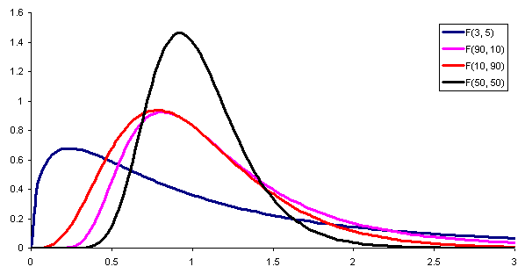

Figure 1. F Distributions for Various (df 1, df 2)

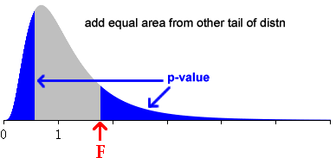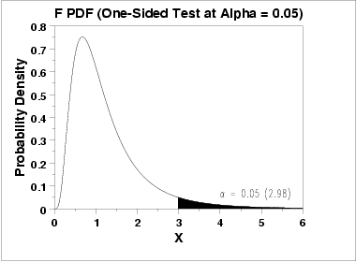

In theory, the F-distribution is two-tailed. That is, if F < 1 we can integrate the distribution from 0 to F, or if F > 1, from F to +inf. However (possibly due to considerations of numerical accuracy) the convention is to always integrate the positive tail.

For this reason we always place the larger of the two variance estimates in the numerator, and choose F distribution with:

(n₁ – 1, n₂ – 1) df when $s_{1}^{2}≥s_{2}^{2}$, or
(n₂ – 1, n₁ – 1) df when $s_{1}^{2}<s_{2}^{2}$.

Excel

In Excel we can calculate F as the ratio sample variances, and then use the FDIST function to compute the p-value of F.

= FDIST(F, df1, df)

Where:
- The larger variance should always be placed in the numerator.
- Multiply result × 2 for a two-tailed test.

To ensure the larger variance is always in the numerator, we use conditional logic in the cell formula for F:

Conditional logic in Excel: =IF(logical expression, formula if TRUE, formula if FALSE)

So, formula for F:

=IF(var1>var2, var1/var2, var2/var1)

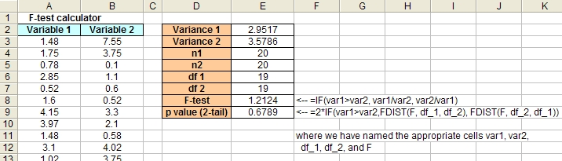

Assumption of F test of variances: In the populations from which the samples were obtained the variable is normally distributed.

3. One-way ANOVA in JMP

The procedure for performing a one-way ANOVA with JMP is basically the same as with an independent groups t-test. Functionally, the only difference is that you now have more than two groups. This assumes you have a variable that identifies group.

Follow the same steps previously described for an independent groups t-test. When JMP supplies the initial report, click the red arrow to display a drop-down menu; and choose: Means/Anova/Pooled t.

